Bootstrap makes available four classes:

-xs extra small

-sm small

-md medium screens

-lg for large screens

col-sm-5 -> occupies 5 columns

**If the screens are XS then they appear as 12 columns each div so col-xs-12 is used.**

<div class = "col-xs-12 col-sm-5">

<div class = "col-xs-12 col-sm-7">

**If the screens are SM or BIGGER then they appear as 5 columns each div so col-sm-5 is used.**

<div class = "col-xs-12 col-sm-5"> <div class = "col-xs-12 col-sm-7">

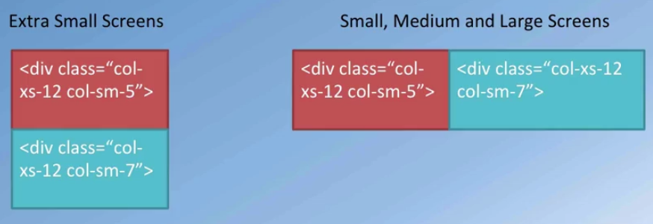

**Push and pull classes**

**In this case if the screen is small or bigger, the first div will use the last 7 rows and the scond div will use the first 5 rows.**

<div class = "col-xs-12 col-sm-5 col-sm-push-7"> <div class = "col-xs-12 col-sm-7 col-sm-pull-5">

**Column Offsets**

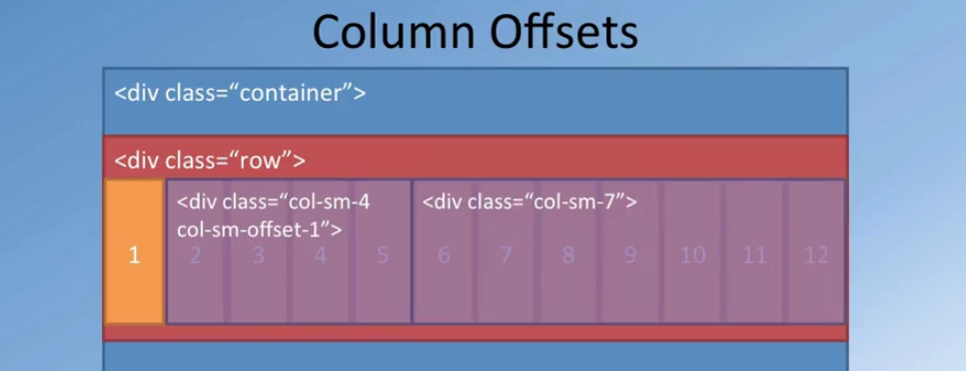

**Nesting columns**

Introduce another row in the col-sm-7 class. Thar row is split again into 12 columns which can be accessed using the same classes.

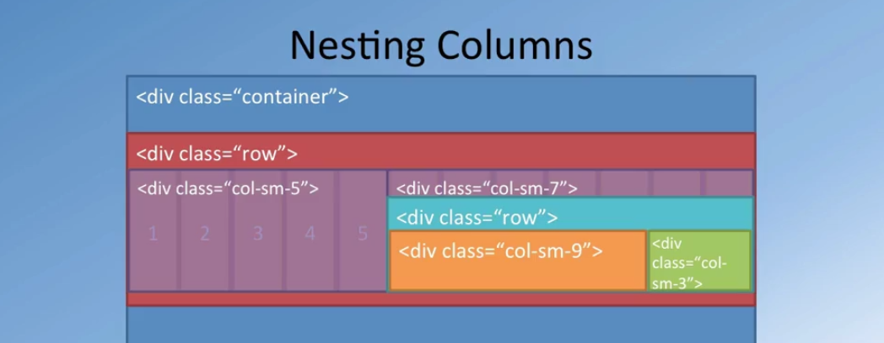

<div class="container">

<div class="row">

<div class="**col-xs-12 col-sm-3 col-sm-push-9**">

<p style="padding:20px;"></p>

<h3 align=center>Our Lipsmacking Culinary Creations</h3>

</div>

<div class="**col-xs-12 col-sm-9 col-sm-pull-3**">

<h2>Uthappizza</h2>

<p>A unique combination of Indian Uthappam (pancake) and Italian pizza, topped with Cerignola olives, ripe vine cherry tomatoes, Vidalia onion, Guntur chillies and Buffalo Paneer.</p>

<p><a href="#">More &raquo;</a></p>

</div>

</div>

**Result**

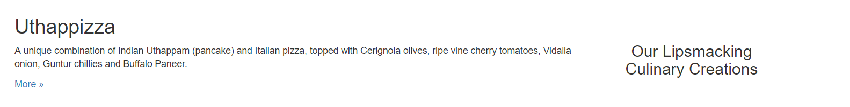

What happens is :

* **If the screen is XS**

the title will be on top of the description

* **If the screen is SM or bigger**

The title will appear first (first 3 columns) and the description will be to the right (last 9 columns). Because of the **col-sm-push-9** the title will be moved to the last 3 columns and the because of the **col-sm-pull-3** the description will be moved to the first 9 columns.